WOMEN OF POLISH HERITAGE
CELEBRATE WOMEN’S HISTORY MONTH

Marie Skłodowska-Curie  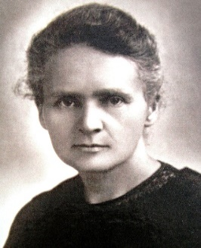  Discovered The Science Of Radioactivity | Irena Sendler  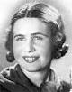  Her group saved 5,000 Jewish children from Warsaw ghetto | Maria Siemionow  Performed The First Face Transplant In The United States
Saint Faustina Kowalska  The Apostle of Divine Mercy | Barbara Mikulski  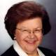  The Longest-Serving Woman In The United States Congress | Martha Stewart  Businesswoman, Writer, And  Television Personality
Susan Wojcicki  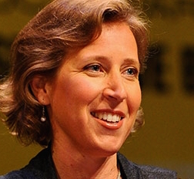  Technology Executive And  CEO Of YouTube | Helena Rubinstein  Polish American cosmetics entrepreneur | Rita Cosby  News Anchor, Correspondent, Radio Host, Author
Laura Ingraham  TV Commentator, Radio Host, Author | Agnieszka Radwanska  Women’s Tennis Association Tour Ranked No. 5 | Mika Brzezinski  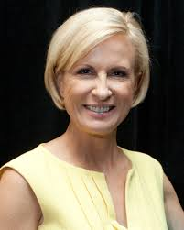  MSNBC Television Host, Correspondent, Author

